Defining the hospital management schema

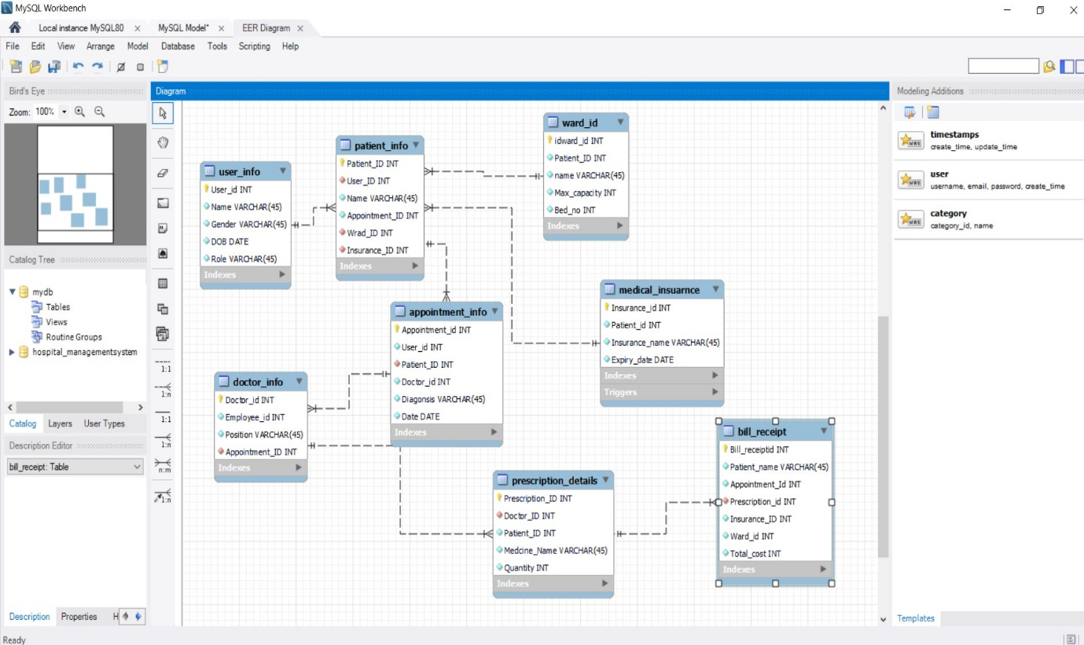

Ward_id

SELECT * FROM hospital_managementsystem.ward_id;

INSERT INTO `hospital_managementsystem`.`ward_id` (`idward_id`, `Patient_ID`, `name`, `Max_capacity`, `Bed_no`) VALUES ('502', '1002', 'PQR', '5', '11');

INSERT INTO `hospital_managementsystem`.`ward_id` (`idward_id`, `Patient_ID`, `name`, `Max_capacity`, `Bed_no`) VALUES ('503', '1003', 'RST', '6', '12');

INSERT INTO `hospital_managementsystem`.`ward_id` (`idward_id`, `Patient_ID`, `name`, `Max_capacity`, `Bed_no`) VALUES ('504', '1004', 'WXY', '5', '13');

Medical_isnurance

SELECT * FROM hospital_managementsystem.medical_insuarnce;

INSERT INTO `hospital_managementsystem`.`medical_insuarnce` (`Insurance_id`, `Patient_id`, `Insurance_name`, `Expiry_date`) VALUES ('1102', '1002', 'LIC', '2024-02-16');

INSERT INTO `hospital_managementsystem`.`medical_insuarnce` (`Insurance_id`, `Patient_id`, `Insurance_name`, `Expiry_date`) VALUES ('1103', '1003', 'LIC', '2024-02-18');

INSERT INTO `hospital_managementsystem`.`medical_insuarnce` (`Insurance_id`, `Patient_id`, `Insurance_name`, `Expiry_date`) VALUES ('1104', '1004', 'LIC', '2024-02-11');

.user_info;

SELECT * FROM hospital_managementsystem.user_info;

INSERT INTO `hospital_managementsystem`.`user_info` (`User_id`, `Name`, `Gender`, `DOB`) VALUES ('2002', 'PQR', 'M', '2002-04-20');

INSERT INTO `hospital_managementsystem`.`user_info` (`User_id`, `Name`, `Gender`, `DOB`) VALUES ('2003', 'RST', 'F', '2000-05-09');

INSERT INTO `hospital_managementsystem`.`user_info` (`User_id`, `Name`, `Gender`, `DOB`) VALUES ('2004', 'WXY', 'M', '2001-04-20');

patient_info;

SELECT * FROM hospital_managementsystem.patient_info;

INSERT INTO `hospital_managementsystem`.`patient_info` (`Patient_ID`, `User_ID`, `Name`, `Appointment_ID`, `Wrad_ID`, `Insurance_ID`) VALUES ('1002', '2002', 'PQR', '102', '502', '1102');

INSERT INTO `hospital_managementsystem`.`patient_info` (`Patient_ID`, `User_ID`, `Name`, `Appointment_ID`, `Wrad_ID`, `Insurance_ID`) VALUES ('1003', '2003', 'RST', '103', '503', '1103');

INSERT INTO `hospital_managementsystem`.`patient_info` (`Patient_ID`, `User_ID`, `Name`, `Appointment_ID`, `Wrad_ID`, `Insurance_ID`) VALUES ('1004', '2004', 'WXY', '104', '504', '1104');

appointment_info;

SELECT * FROM hospital_managementsystem.appointment_info;

INSERT INTO `hospital_managementsystem`.`appointment_info` (`Appointment_id`, `User_id`, `Patient_ID`, `Doctor_id`, `Diagonsis`, `Date`) VALUES ('102', '2002', '1002', '2', 'Cough', '2024-01-15');

INSERT INTO `hospital_managementsystem`.`appointment_info` (`Appointment_id`, `User_id`, `Patient_ID`, `Doctor_id`, `Diagonsis`, `Date`) VALUES ('103', '2003', '1003', '3', 'Cold', '2024-01-17');

INSERT INTO `hospital_managementsystem`.`appointment_info` (`Appointment_id`, `User_id`, `Patient_ID`, `Doctor_id`, `Diagonsis`, `Date`) VALUES ('104', '2004', '1004', '1', 'Fever', '2024-01-23');

doctor_info;

SELECT * FROM hospital_managementsystem.doctor_info;

INSERT INTO `hospital_managementsystem`.`doctor_info` (`Doctor_id`, `Employee_id`, `Position`, `Appointment_ID`) VALUES ('2', '002', 'Senior', '102');

INSERT INTO `hospital_managementsystem`.`doctor_info` (`Doctor_id`, `Employee_id`, `Position`, `Appointment_ID`) VALUES ('3', '003', 'Junior', '103');

INSERT INTO `hospital_managementsystem`.`doctor_info` (`Doctor_id`, `Employee_id`, `Position`, `Appointment_ID`) VALUES ('4', '004', 'Senior', '104');

prescription_details;

SELECT * FROM hospital_managementsystem.prescription_details;

INSERT INTO `hospital_managementsystem`.`prescription_details` (`Prescription_ID`, `Doctor_ID`, `Patient_ID`, `Medcine_Name`, `Quantity`) VALUES ('6666', '2', '1002', 'adderall', '4');

INSERT INTO `hospital_managementsystem`.`prescription_details` (`Prescription_ID`, `Doctor_ID`, `Patient_ID`, `Medcine_Name`, `Quantity`) VALUES ('7777', '3', '1003', 'ativan', '4');

INSERT INTO `hospital_managementsystem`.`prescription_details` (`Prescription_ID`, `Doctor_ID`, `Patient_ID`, `Medcine_Name`, `Quantity`) VALUES ('8888', '4', '1004', 'amoxicillin', '4');

bill_receipt;

SELECT * FROM hospital_managementsystem.bill_receipt;

INSERT INTO `hospital_managementsystem`.`bill_receipt` (`Bill_receiptid`, `Patient_name`, `Appointment_Id`, `Prescription_id`, `Insurance_ID`, `Ward_id`, `Total_cost`) VALUES ('9902', 'PQR', '102', '6666', '1102', '502', '7000');

INSERT INTO `hospital_managementsystem`.`bill_receipt` (`Bill_receiptid`, `Patient_name`, `Appointment_Id`, `Prescription_id`, `Insurance_ID`, `Ward_id`, `Total_cost`) VALUES ('9903', 'RST', '103', '7777', '1103', '503', '10000');

INSERT INTO `hospital_managementsystem`.`bill_receipt` (`Bill_receiptid`, `Patient_name`, `Appointment_Id`, `Prescription_id`, `Insurance_ID`, `Ward_id`, `Total_cost`) VALUES ('9904', 'WXY', '104', '8888', '1104', '504', '11000');

Queries to perform:

Query to query to register new user role and personas

INSERT INTO `hospital_managementsystem`.`user_info` (`User_id`, `Name`, `Gender`, `DOB`) VALUES ('2002', 'PQR', 'M', '2002-04-20');

INSERT INTO `hospital_managementsystem`.`user_info` (`User_id`, `Name`, `Gender`, `DOB`) VALUES ('2003', 'RST', 'F', '2000-05-09');

upadated query

UPDATE `hospital_managementsystem`.`user_info` SET `Role` = 'Patient' WHERE (`User_id` = '2001');

UPDATE `hospital_managementsystem`.`user_info` SET `Role` = 'Doctor' WHERE (`User_id` = '2002');

UPDATE `hospital_managementsystem`.`user_info` SET `Role` = 'Doctor' WHERE (`User_id` = '2003');

UPDATE `hospital_managementsystem`.`user_info` SET `Role` = 'Patient' WHERE (`User_id` = '2004');

Query to query to add list of patient tagged by date

SELECT *FROM appointment_info

WHERE DATE(Date) BETWEEN '2024-01-17' AND '2024-01-23'

Query to fetech required detail of particular patient

Select Appointment_ID,Name from patient_info

where Patient_ID='1001';

Query to prepare bill at end of checkpoint

Select bill_receiptid,Patient_name,Appointment_id,prescription_id,insurance_id,ward_id,total_cost

from bill_receipt;

Query to fetech and show related data(JOINS)

#Inner join

SELECT Name

FROM patient_info

INNER JOIN appointment_info ON patient_info.Patient_ID = appointment_info.Patient_ID;

#left outer join

SELECT Doctor_id

FROM appointment_info

LEFT JOIN doctor_info ON appointment_info.Appointment_id = doctor_info.Appointment_ID;

#right outer join

SELECT Position

FROM appointment_info

RIGHT JOIN doctor_info ON appointment_info.Appointment_id = doctor_info.Appointment_ID;

#self join

SELECT *

FROM prescription_details, bill_receipt

WHERE prescription_details.Prescription_id = bill_receipt.Bill_receiptid;

CREATE VIEW [appointment_info] AS

SELECT Patient_ID,Doctor_ID

FROM

WHERE Patient_ID = '100';

Necessary trigger to trigger Expiry limit

CREATE DEFINER=`root`@`localhost` TRIGGER `medical_insuarnce_AFTER_INSERT` AFTER INSERT ON `medical_insuarnce` FOR EACH ROW BEGIN

IF NEW.Expiry_date >= DATE_ADD(CURDATE(), INTERVAL 7 DAY) THEN

SIGNAL SQLSTATE '45000' SET MESSAGE_TEXT = 'Alert:!';

END IF;

END

optimizing bill using stored procedures

CREATE PROCEDURE optimized_bill

AS

select*from bill_details;

GO;

Output Snapshots:

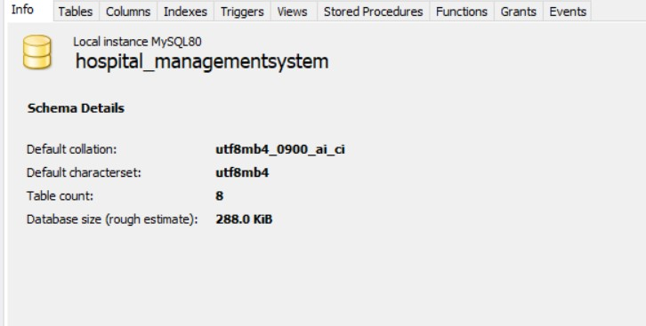

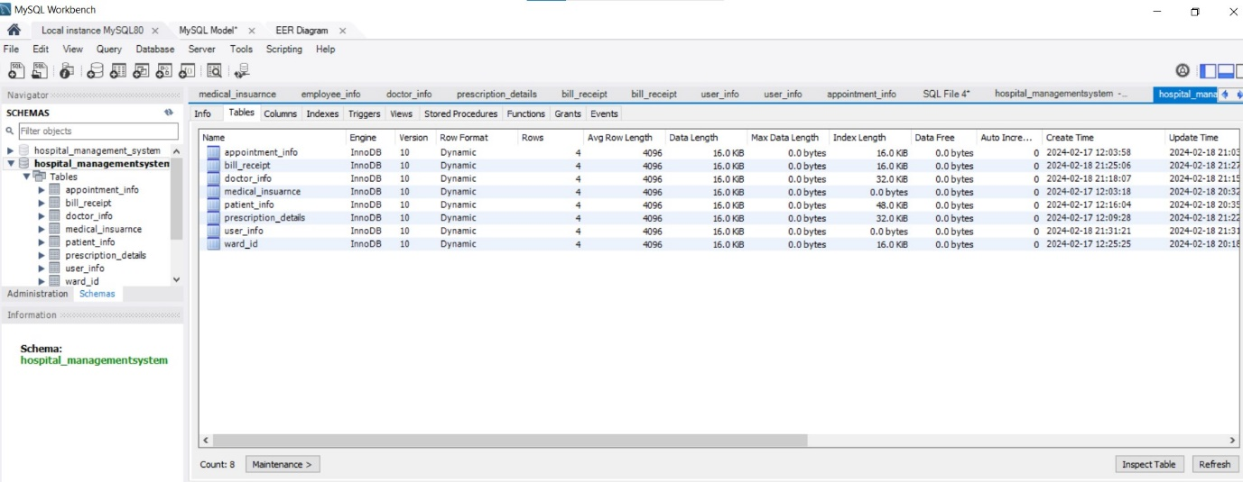

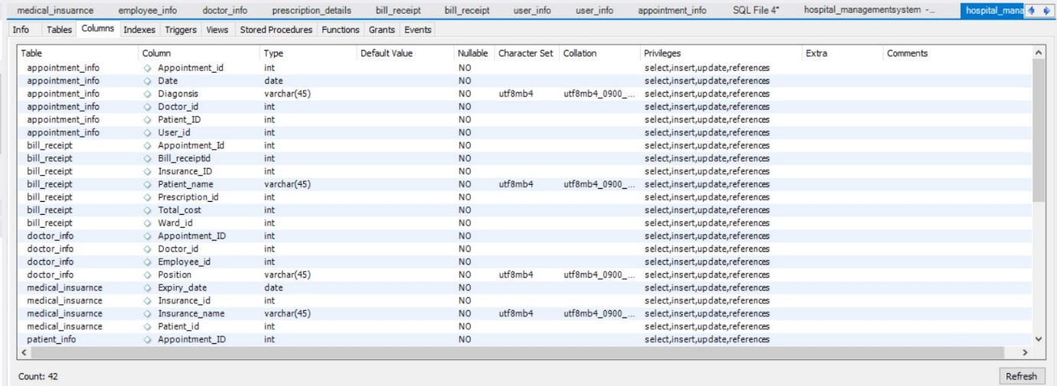

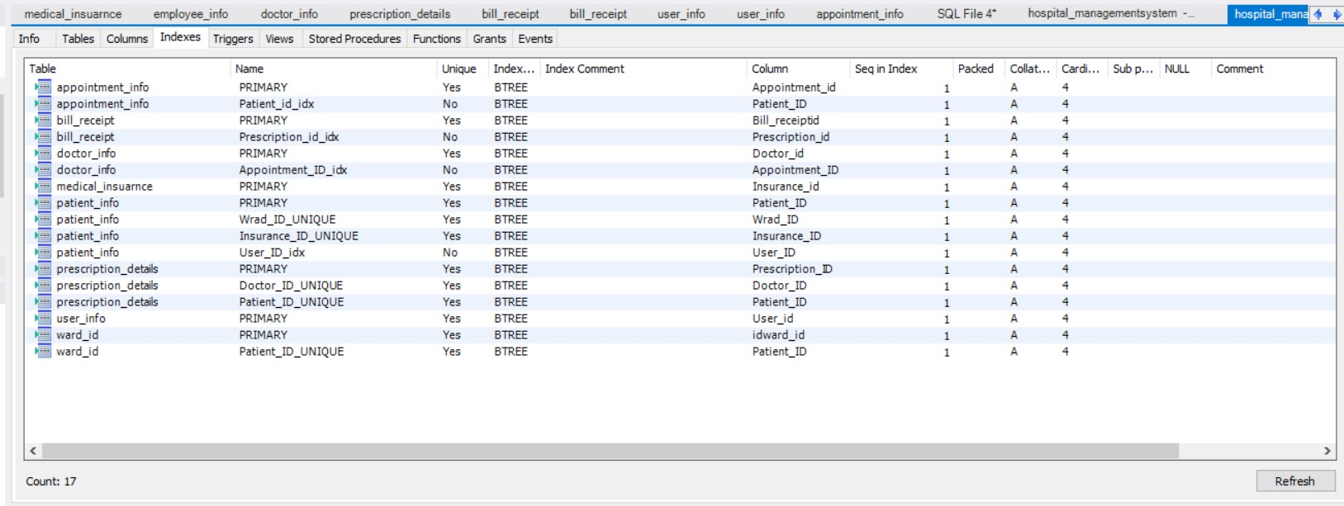

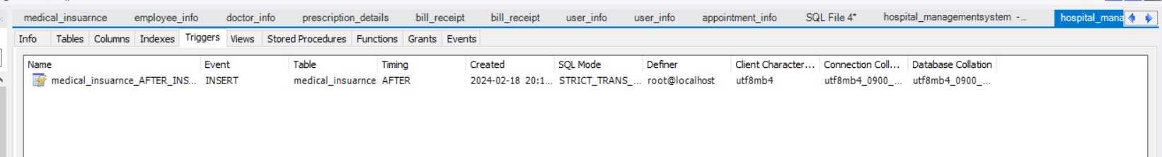

Team collaboration activity:

